


Oracle Fusion Cloud Integration between Kyriba and US Banks in Travel and Hospitality Industry – <Financial Holding Company #19>
Market Offering:
Package(s): Oracle Fusion Financials and Kyriba
Authors: Rutuja Suryawanshi
Date: May 2018

CONTENTS

CONTENTS 2
INTRODUCTION 3
DESIGN 4
DATA SOURCE 5
PROBLEM DEFINITION 19
HIGH LEVEL SOULTION 27
POST IMPLEMENTATION RESULT 28
CONCLUSION 28
REFERENCES 29
AUTHOR(S) BIO 29

INTRODUCTION

Kyriba is the global leader in Cloud financial and treasury management solutions that enable forward-thinking treasury and finance teams to optimize cash and risk management, payments and working capital strategies. Kyriba delivers a highly secure 100% SaaS platform, superior bank connectivity and a seamlessly integrated solution set for tackling many of today’s most complex financial and treasury challenges.
As a part of Bank Payments against Invoices, the client and other stakeholders expect the integration team to send payment files that provides payments and bank details from the Accounts Payable (AP) module in Oracle Fusion to Kyriba. Generating such payment files involves fetching data from Oracle Fusion Accounts Payable module while making payment, identifying the information and bank details, payment type should be in a presentable manner. However, this process when done manually would be time consuming, and monotonous in nature.
This paper provides an overview and guide for the most typical integration options for the AP Invoice Payment business processes. The first option is a full Vendor Payment process in Oracle Fusion with direct integration with Kyriba. This option allows you to manage invoice payments from your existing payables system. This option has number of limitations to consider, but does allow companies to leverage specific bank formats or government reporting requirements that may have already been developed in your existing systems. The rest of this paper provides Kyriba and Banks Payment approaches, describes the available integration technologies, and refers you to additional sources of information. With a successful co-existence strategy, you can gain the benefits from Oracle Fusion and start reaping business benefits as quickly as possible.
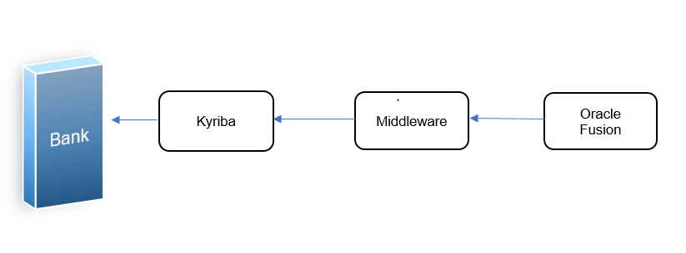
Figure 1: Flow diagram of the example used in this paper
DESIGN

The key component includes data source(s).
- Oracle Fusion ERP: Invoice and related Payments for Disbursement in .xml file format.
- Kyriba: Data fetched is organized and mapped from .xml file.
- Bank: Data sent from Kyriba to disburse payments against AP Invoices to the vendors from correct Bank.
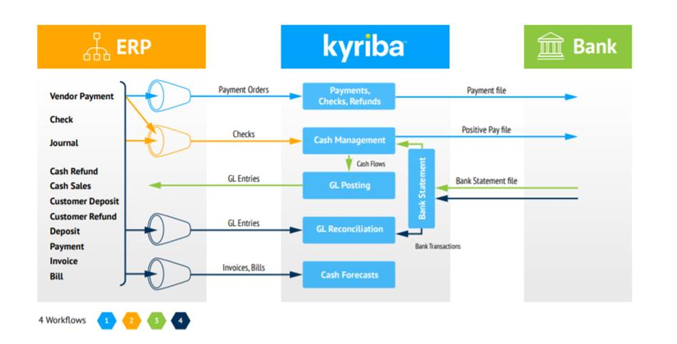

Figure 2: Basic Design Flow Diagram

PROBLEM DEFINITION

Kyriba is a critical set of software applications. Kyriba programming sorts out financial and operational information, so organizations can streamline reporting and planning cycles and enhance the effectiveness of asset assignment inside the business. Since Kyriba programming is basically expected to advance the allotment of Finances, it should be incorporated with Oracle Fusion systems.

By incorporating ERP systems with Kyriba systems, organizations can merge monetary and operational information into a solitary stage for arranging and decision making. In turn, everyday reconciliations can depend on itemized operational information, while financial planning and forecasting can rely on summarized data from across the enterprise.

Why Kyriba?
Kyriba adds following solutions to Oracle: -
- Bank Communication - SaaS connections to 400+ global banks
- Cash Management and Forecasting - 100% Cash Visibility, real Forecasting
- Payments - Payment Workflow, Straight Through Processing, Impregnable defense

By integrating Kyriba with Oracle Fusion our enterprise can:

- Connect all data sources together into a single version of the truth
- Increase the accuracy of resource management, planning, and allocation
- Improve the quality and reliability of management information
- And increase the efficiency of data management and analysis
- The two software applications create a necessary and mutually beneficial synergy that can fuel the accuracy and efficiency of business processes. You’ll be able to integrate all financial data into one place, so business decisions and resource planning are based on the most accurate and complete view of the company.

High level solution

This is one of many problems associated with integrating two or many ERP systems. In a perfect world, implementing a single but flexible ERP package that can handle the needs of all sites in one database is the right answer. There are some good ERP packages that address multi-site “mix mode” functioning.
We need to achieve the below: -
Synchronize between Oracle Fusion Payment, Middleware and Kyriba.
The diagram below shows the SFTP configuration in an Oracle Fusion environment. You need to collaborate with both the financial institution and Oracle Fusion Applications to exchange necessary information.
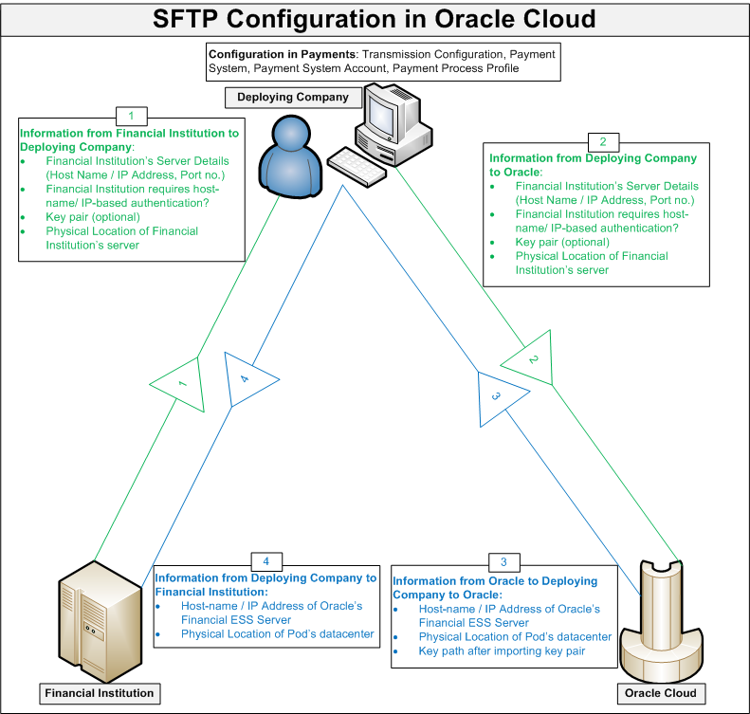
Figure 3: SFTP Configuration

Quick solution setup — communication between Oracle Fusion Accounts Payable and Kyriba this solution should fully operational.
- The payments defined are Check, ACH and inhouse payment method under various <Financial Holding Company #19> accounts.
- Need to assure every Payment file has unique reference number which works as an identifier in Kyriba system to differentiate Oracle Fusion payments disbursed for respective banks.
- Every file generated should have unique name to avoid reprocessing of payment files pushed at static location.

Solution Detail

Despite of challenges to integrate Oracle Fusion to Kyriba, we have designed a solution to sync invoice payment files which colludes with Kyriba system.
1.Summary of Process Flow: -
- Create and approve Invoice in Account Payables Cloud
- Create Payment Batch for <Financial Holding Company #19> Bank account and record invoices in payment process profiles
- Selection criteria for Payment Process Batch can be selected as per Business needs.
- Disburse related payment batch.
- Automatic Publish Payment data in XML format at static location using Auto Transmit background process
- Kyriba inbound payment invoices and send to Bank for Payments
- Bank send payment files in BAI2 format
- Oracle inbound BAI2 files in Cash Management.

2.Financial Configurations

Create an implementation project that includes the Define Financials Configuration for Rapid Implementation task list from the Manage Implementation Projects page in the Setup and Maintenance work area. This task list focuses only on the critical setup steps that are required in most cases and minimizes the time needed for you to complete the setups. You can customize the task list and delete the task lists for the applications you are not implementing or manually add the standard Financials offering task lists and tasks to your rapid implementation project to change or update your setup.

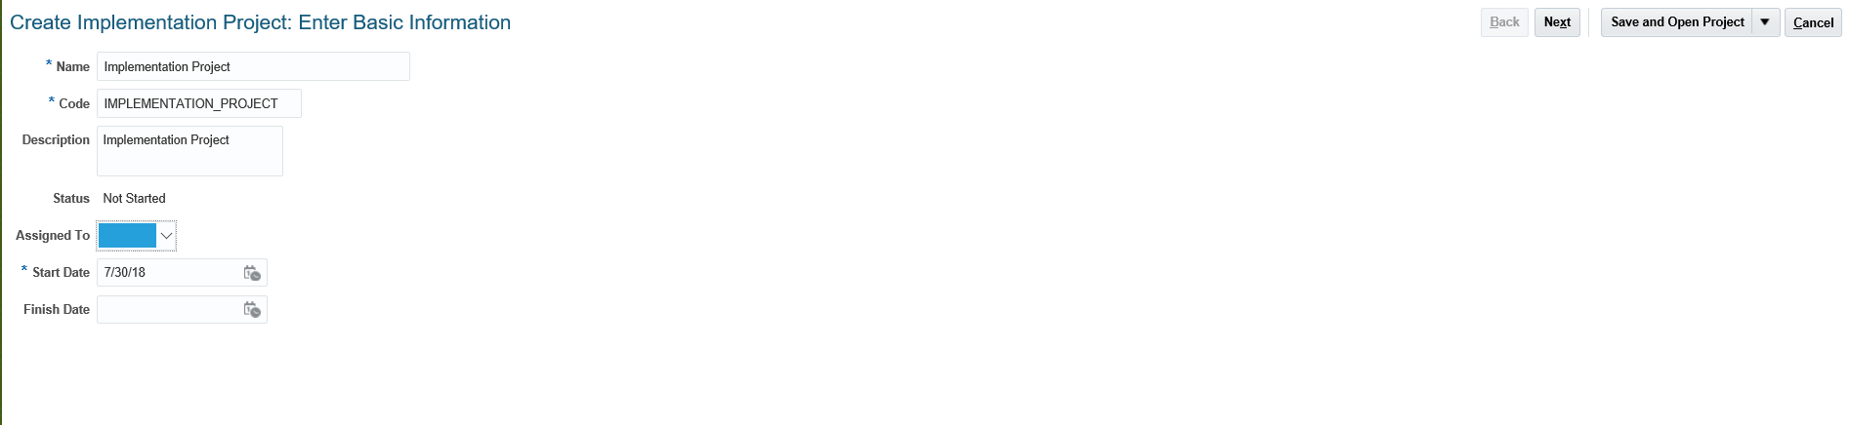

3.Kyriba and Oracle Fusion Configuration Setup: -

- Obtain the following details from your financial institution:

- The financial institution’s implementation guide that describes technical details of SFTP connectivity
- The financial institution’s SFTP server details, such as the IP address, port number, SFTP account name, password, remote directory, and file naming convention for both the production server and the test server. Important: Oracle Network Security requires IP address not the hostname of the SFTP server.
- Whether a whitelist of the host name/IP address of Oracle Fusion Applications’ SFTP server is necessary
- Key pair data if SFTP authentication is required
  - Check with your financial institution to determine whether client-side SFTP authentication is required through a predetermined key pair.
  - If a remote financial institution’s server requires client authentication, where Oracle Fusion Applications presents a key to establish its identity, then obtain the key pair from your financial institution and import it into the pod.
  - If your financial institution expects you to provide the public key file, then you must retrieve the key pair generated in the Fusion server and share the public key file with your financial institution.
- Physical location of the financial institution’s SFTP server

Important: You must ask your financial institution to assign you a SFTP server on the same continental region as your pod’s data centre.

Reason: Per cloud network security standards, a remote SFTP server must be on the same continental region as the POD. For example, it may not be possible for a European customer to communicate directly with its American bank unless the American bank has a European data center.

- Log a service request if you need following (optional):

- Request generation of the key pair in the Fusion server if your financial institution is expecting a public key file from you for SFTP authentication. (Note: If your bank has provided you key file then you need to import it)
- Request Oracle’s Firewall IP if your financial institute needs to whitelist it.

- Create SFTP_THROUGH_PROXY Lookup:

SFTP through proxy functionality requires SFTP_THROUGH_PROXY lookup to be created in Fusion Applications. Follow the steps below to create the lookup.

    - From Setup and Maintenance, query Manage Standard Lookups task
    - Under Search Results section, click on Add (+ sign) to add a new lookup as shown below:

- Lookup Type = SFTP_THROUGH_PROXY
- Meaning = SFTP Connection Via Proxy
- Description = SFTP Connection Via Proxy
- Module = Payments
- Customization Level = User

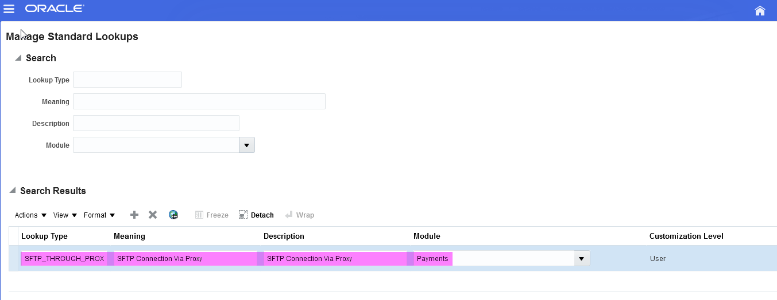

    - Save and click on Add to add a new Lookup Code for newly created Lookup Type:

- Lookup Code = Y
- Meaning = Y
- Description = Turns on SFTP Over Proxy

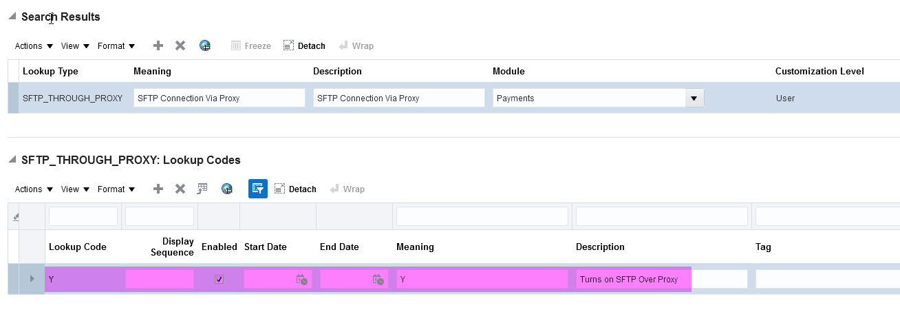

    - Save and close

- Configure Payments.

To configure a transmission setup using SFTP for disbursement payment files or positive pay files, perform the following steps:

- Import Security Key (Optional Step): If your bank has provided you security key file then you need to import that using the below steps:
  - First upload the file in Universal Content Manager (UCM) using File Import and Export. Use the account “fin/payments/import”.
  - Go to ESS submission page and select “Import Security Credential Job”
  - Enter the parameters as mentioned below:
    - Retrieval Transmission Configuration: Null
    - Credential File Type: Use Secure Shell for SFTP based integration with bank.
    - Security Credential Name: Identifier for the credential; does not need to be same as original file name. It will appear in the LOV for Client Private Key File attribute in the SFTP transmission configuration.
    - UCM File: Select file uploaded in UCM from the dropdown.
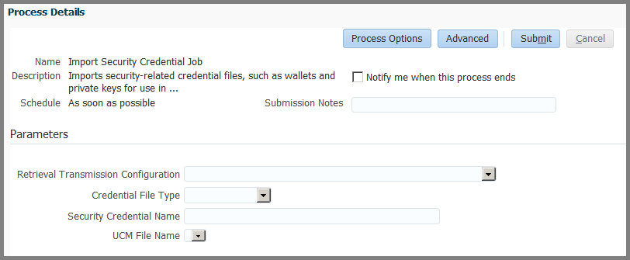
- Create a new transmission configuration with a SFTP protocol by selecting the SFTP option from the Select Protocol choice list on the Manage Transmission Configurations page and click the Create button.
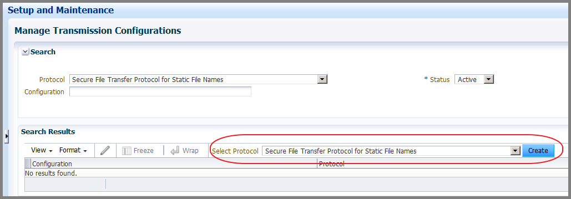
- On the Create Transmission Configuration page, enter the following SFTP transmission parameter values obtained from your bank or payment system:
  - Remote server host name/IP address
  - Port number
  - FTP account user name
  - Password
  - Remote file directory
  - File name
  - Important: Some financial institutions refresh the SFTP server IP address periodically. If the remote server IP is changed, transmission configuration details should be updated to reflect the new IP address. In addition, a service request should be logged (step 2 above) to add the new IP to the security exception list. Failure to follow this process will result in failed payment file transmission.
- Client Private Key File Attribute (Optional Step): If client authentication is required, select the file name from the dropdown, which you have imported as per previous step. If the key pair was generated in the Fusion server via a service request, enter the absolute path of the private key file. In addition, also enter password in Client Private Key Password.

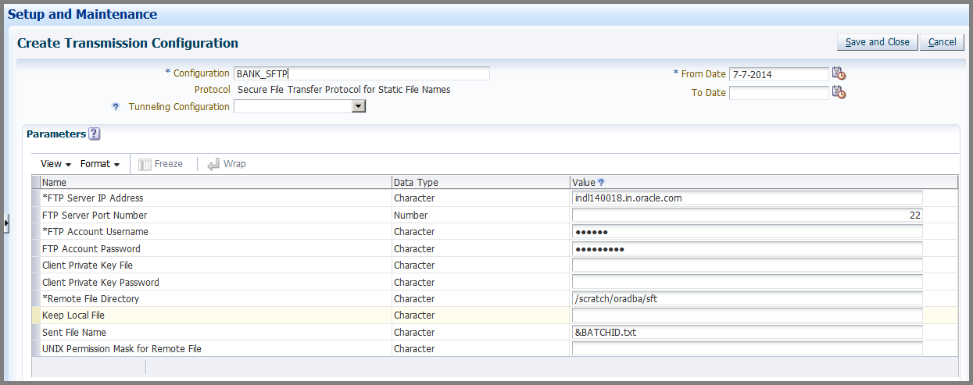
- Create a new payment system for the financial institution that will receive payment files. The new payment system can be your bank or any other service provider.
- On the Manage Payment Systems page, click the Create icon to open the Create Payment System page.

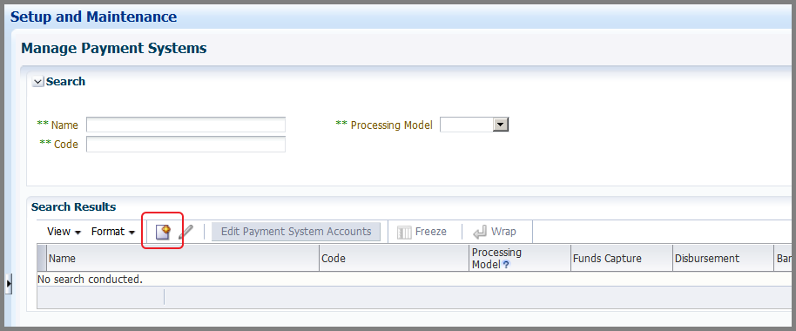
- On the Create Payment System page, perform the following steps:
  - Enable capability for disbursement by selecting the Electronic funds transfer and positive pay check box.
  - Add the payment format to be used in the payment process profile by selecting an option from the choice list in the Formats section.
  - Add the SFTP protocol by selecting the SFTP option from the choice list in the Transmission Protocols section.
  - Add settings required by the payment system, if any.
Payment system settings are in the form of flexible name-value pairs and mapped with the specific attributes in the payment format template. The values for the settings are provided by your payment system.
- Click the Save and Add Accounts button to open the Edit Payment System Accounts page.

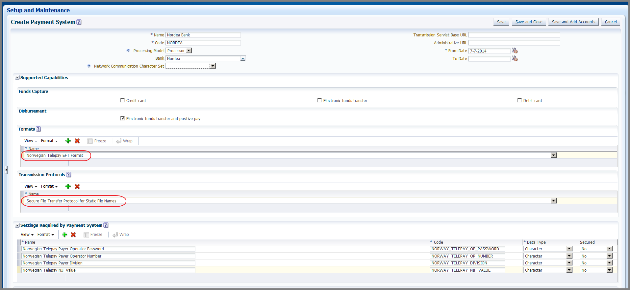
- On the Edit Payment System Accounts page, add a payment system account and enter values for the account settings. These values are generally provided by your bank or payment system. The values you enter are populated in the payment file at the time of formatting.

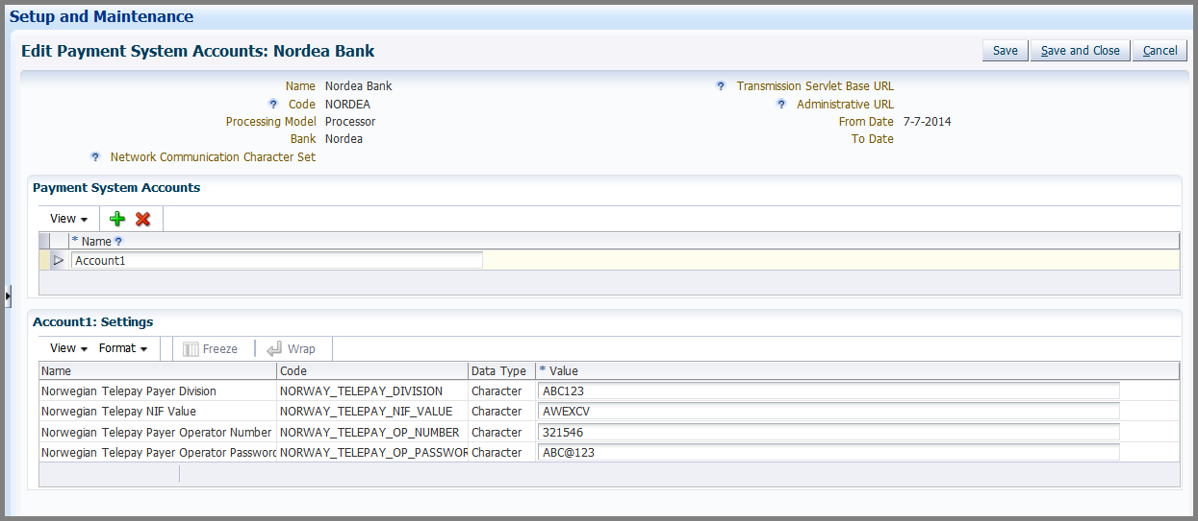
- Configure the payment process profile.
- On the Create Payment Process Profile page, from the Payment File Format choice list, select the same format used by your payment system.
- On the Payment System tab, select the payment system you set up previously from the Payment System choice list.
Once you select it, the Payment System Accounts section renders as seen below.
- From the Payment File Transmission Configuration choice list, select the transmission configuration you set up previously.
- Optionally, select the option to automatically transmit the payment file after formatting

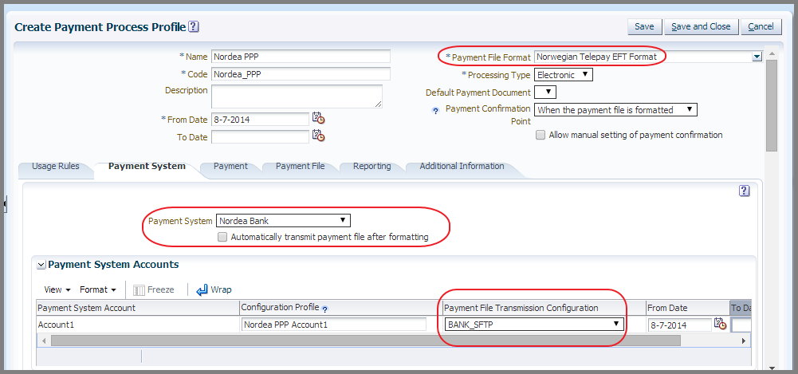

You have now enabled the payment file transmission in the Oracle Fusion Applications environment.
- To transmit a positive pay file to your bank when you print check payments, perform the same steps as described above.
- In the Positive Pay section, select the Positive Pay File Format from the Format choice list and then select the Automatically transmit file check box.

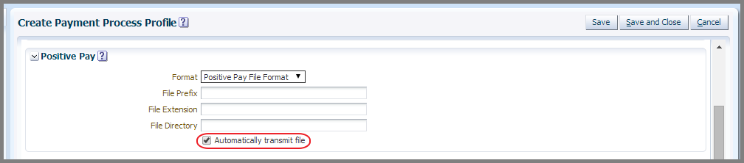

Alternative Approach in the Absence of a Direct SFTP Connectivity:
In very rare cases, a direct SFTP connection to the remote financial system may not be practical, either because of implementation deadlines, or because too many distinct connections are required with the same or different financial institutions. In such cases, an alternative approach may be to use the Universal Content Management (UCM) server. This will be available in Release 9.

Release 9 and Onwards:
Payments supports direct integration with the Universal Content Management (UCM) server. Using Payments, you can transmit the payment file to the UCM server instead of the SFTP server. To transmit a payment file from the UCM server to your financial institution’s SFTP server, you can use a customized process or you can download and transmit the files manually.
On the Create Transmission Configuration page, you can configure a transmission configuration as shown below using the UCM upload protocol.

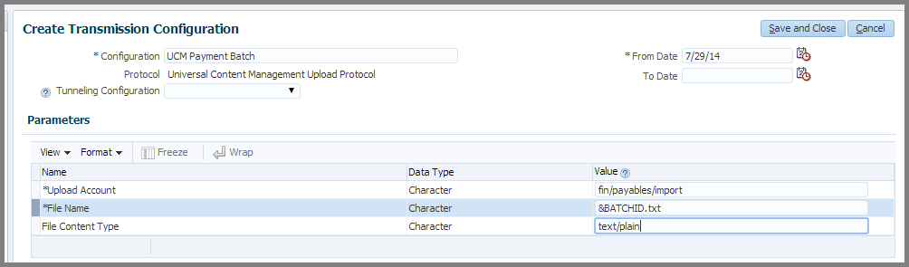
The remaining steps for setting up a Payments transmission configuration in a Cloud environment are the same as previously described.

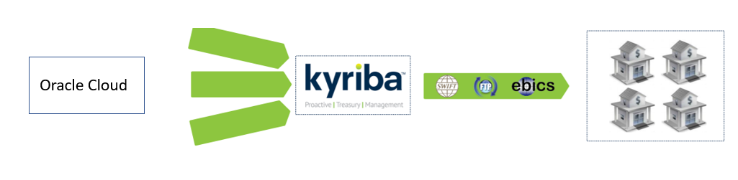
Figure 4: Oracle Sending Payments to Banks Via Kyriba

This setup enables payments to go via SFTP gate way to Kyriba.
Kyriba processes the payment and sends to <Financial Holding Company #19> via Kyriba secure, automated connectivity.
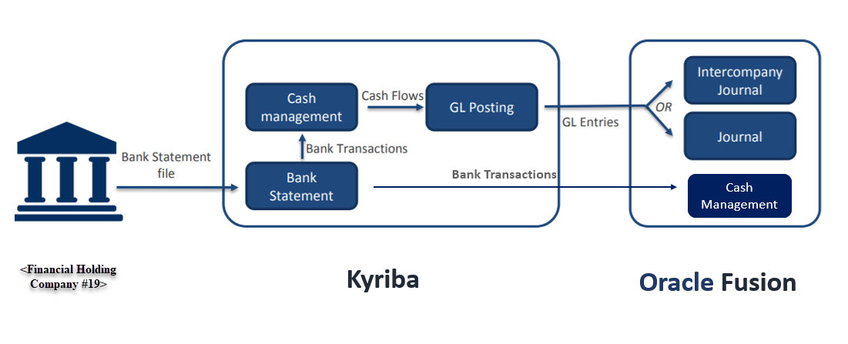
Figure 5: <Financial Holding Company #19> processing payments to Oracle Fusion

<Financial Holding Company #19> processes vendor payments and sends Bank statement files to Kyriba.
Kyriba will send all processed payment in BAI2 format to Oracle. Oracle inbounds the details in Cash Management.

CONCLUSION
There are many advantages of introducing integration with Oracle fusion and other business application as it combats the barriers between the two by meeting the agility and operational cost savings. With Fusion Financials Cloud Service your integration requirements can easily be met with ADF Services, ADF Desktop Integration, File Based Data Import, and Reporting Tools. Fusion Integration Streamlines your digital workforce with an easy, visual, low-code process automation platform that simplifies day to day tasks.

AUTHOR(S) BIO

Rutuja has contributed in Oracle Fusion and EBS deployment projects involving Integrations and Financials suite across industry domains ranging from Services, IT & Manufacturing. Having worked on implementation, upgrade, roll-outs and support engagements, she brings in complementary mix of diverse functional knowledge and sufficient technical expertise on ERP implementation assignments.

APPENDIX

http://www.kyriba.com
https://deloittenet.deloitte.com/

CONTACTS

For more information about this paper, please contact:

Rutuja suryawanshi
Consultant
Deloitte Consulting – USI - Mumbai
rsuryawanshi@deloitte.com

mukesh kumawat
Solution Manager
Deloitte Consulting Ltd, Lake Mary, FL, USA
mukkumawat@deloitte.com

This publication contains general information only and is based on the experiences and research of Deloitte practitioners. Deloitte is not, by means of this publication, rendering business, financial, investment, or other professional advice or services. This publication is not a substitute for such professional advice or services, nor should it be used as a basis for any decision or action that may affect your business. Before making any decision or taking any action that may affect your business, you should consult a qualified professional advisor. Deloitte, its affiliates, and related entities shall not be responsible for any loss sustained by any person who relies on this publication.

Copyright © 20186 Deloitte Development LLC. All rights reserved.

